A.1
CREATE DATABASE SchoolDB;
USE SchoolDB;
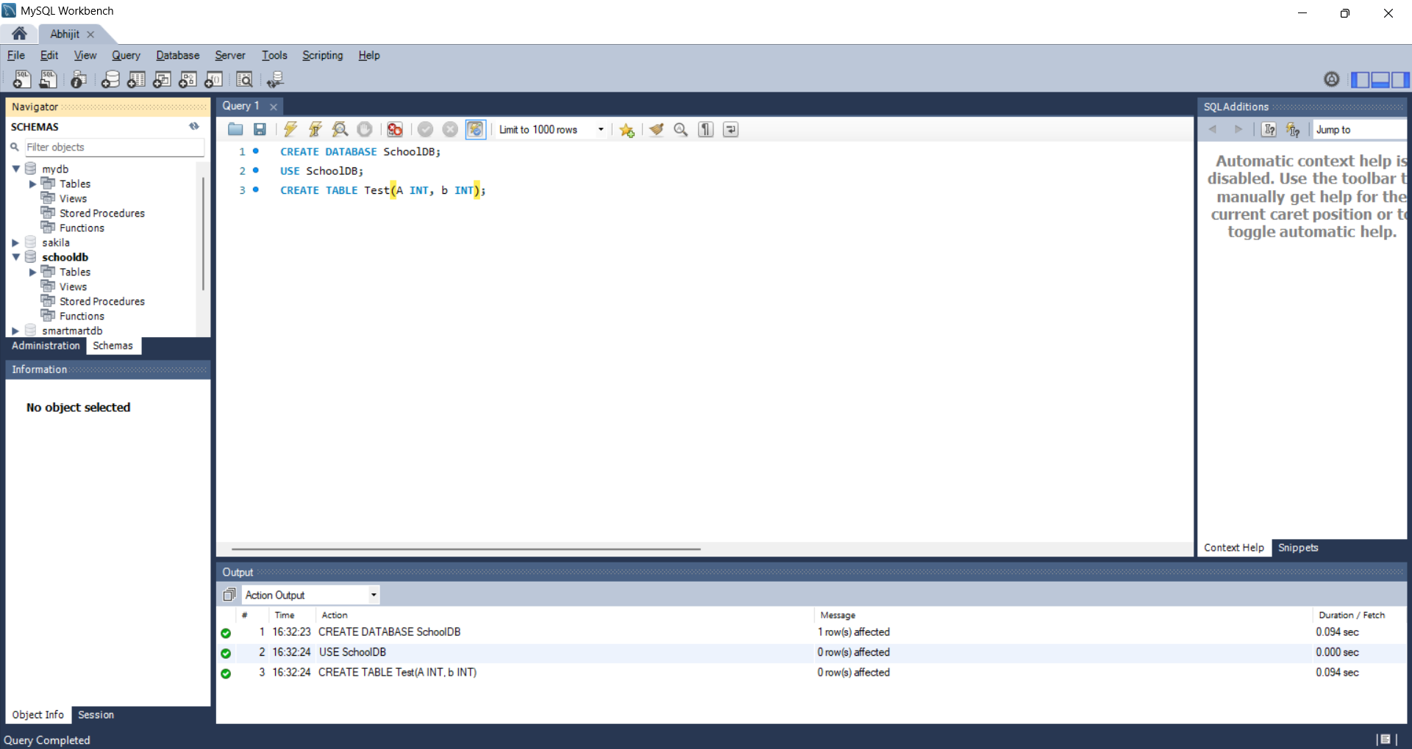

A.2
CREATE TABLE Student(StudentID INT PRIMARY KEY,
StudentName VARCHAR(50) NOT NULL,
Age INT,
ClassName VARCHAR(20),
City VARCHAR(30));
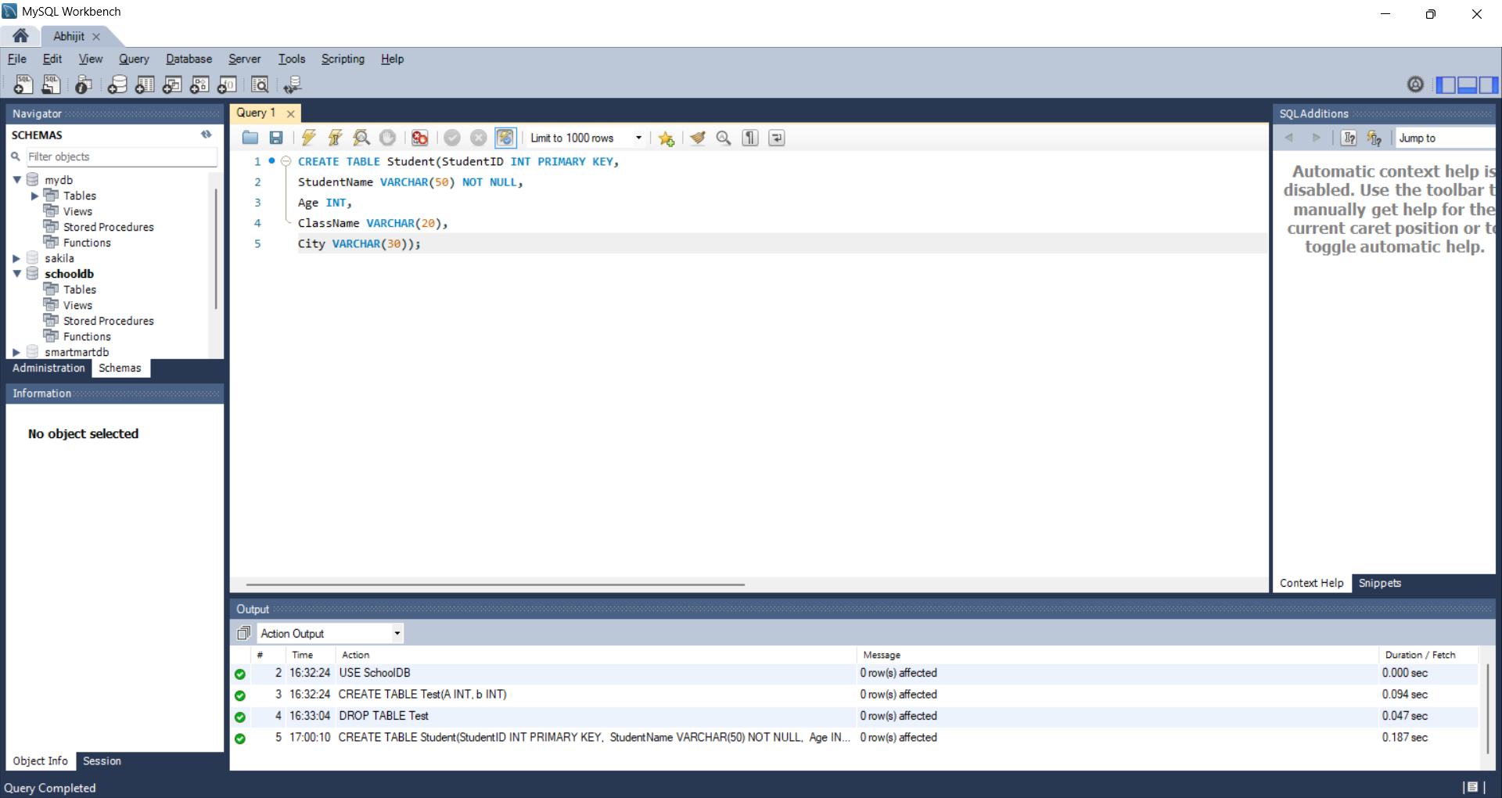

A.3
INSERT INTO Student (StudentID, StudentName, Age, ClassName, City) VALUES
(1, 'Aarav Sharma', 18, 'F.Y B.Sc. IT', 'Pune'),
(2, 'Priya Deshmukh', 19, 'S.Y. BA', 'Mumbai'),
(3, 'Rohan Patil', 20, 'T.Y. B.Com', 'Nashik'),
(4, 'Sneha Kulkarni', 18, 'F.Y. BA', 'Pune'),
(5, 'Aditya Joshi', 21, 'T.Y B.Sc. IT', 'Nagpur'),
(6, 'Isha Pawar', 19, 'S.Y. B.Com', 'Aurangabad'),
(7, 'Karan Shah', 20, 'S.Y B.Sc. IT', 'Mumbai'),
(8, 'Neha Gupta', 18, 'F.Y. B.Com', 'Pune'),
(9, 'Vikram Rane', 22, 'T.Y. BA', 'Kolhapur'),
(10, 'Ananya Iyer', 19, 'S.Y. BA', 'Thane');
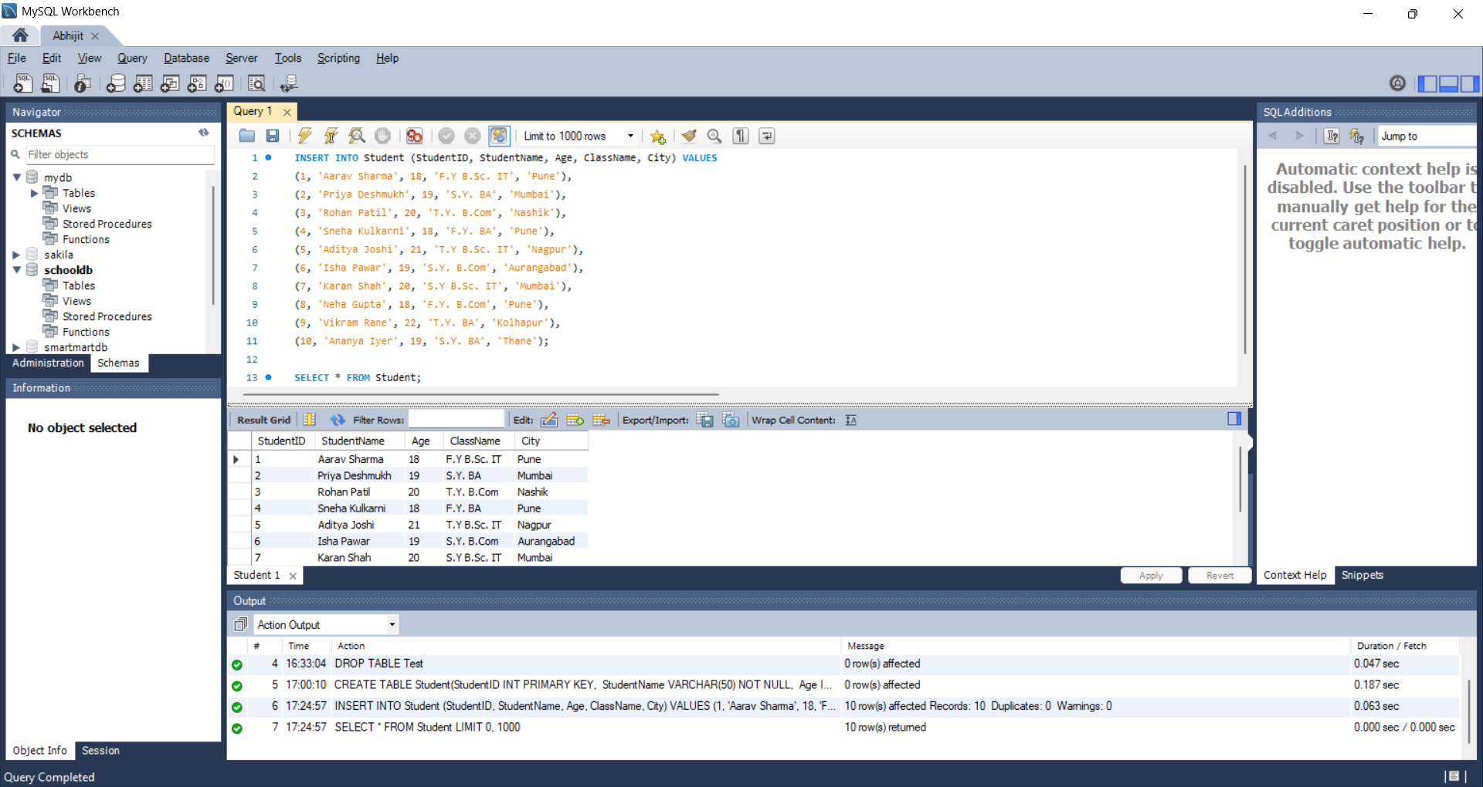

A.4
-- Query to create table
CREATE TABLE Course(CourseID INT PRIMARY KEY,
CourseName VARCHAR(50) NOT NULL,
Duration VARCHAR(20),
Fees DECIMAL (10, 2));
-- Query to insert records
INSERT INTO Course (CourseID, CourseName, Duration, Fees) VALUES
(1, 'B.Sc. IT', '3 Years', 45000.00),
(2, 'BA', '3 Years', 20000.00),
(3, 'B.Com', '3 Years', 25000.00),
(4, 'BCA', '3 Years', 50000.00),
(5, 'MCA', '2 Years', 60000.00);

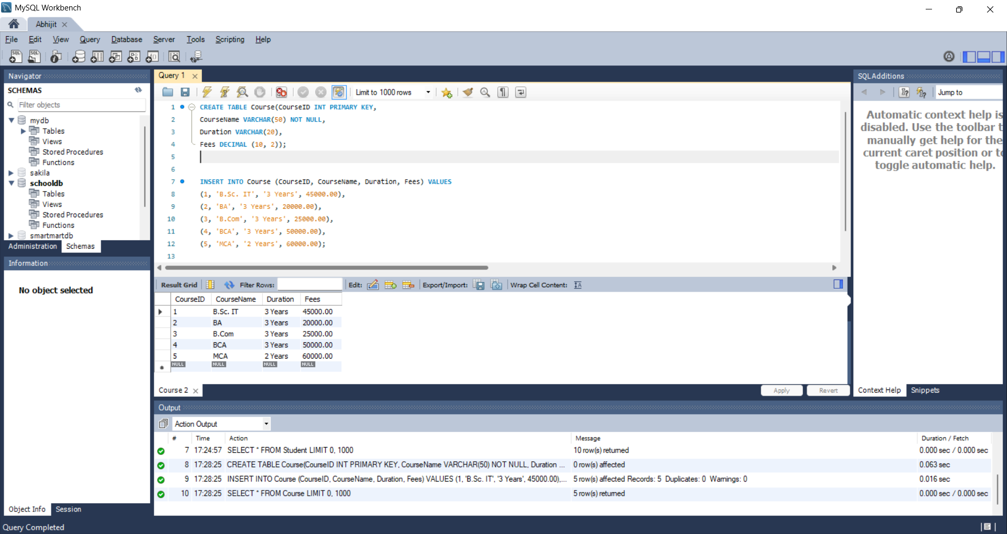

A.5
SELECT StudentName, ClassName, City FROM Student;
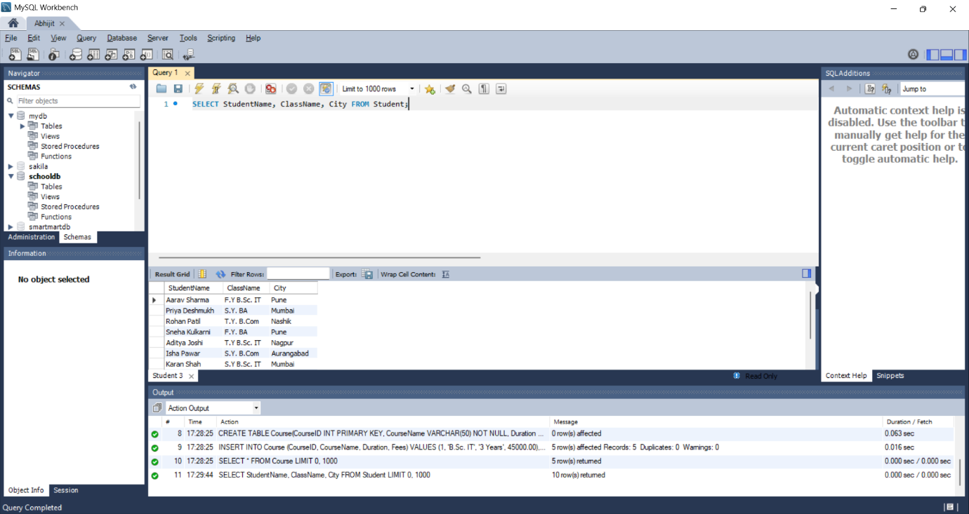

A.6
DESC Student;
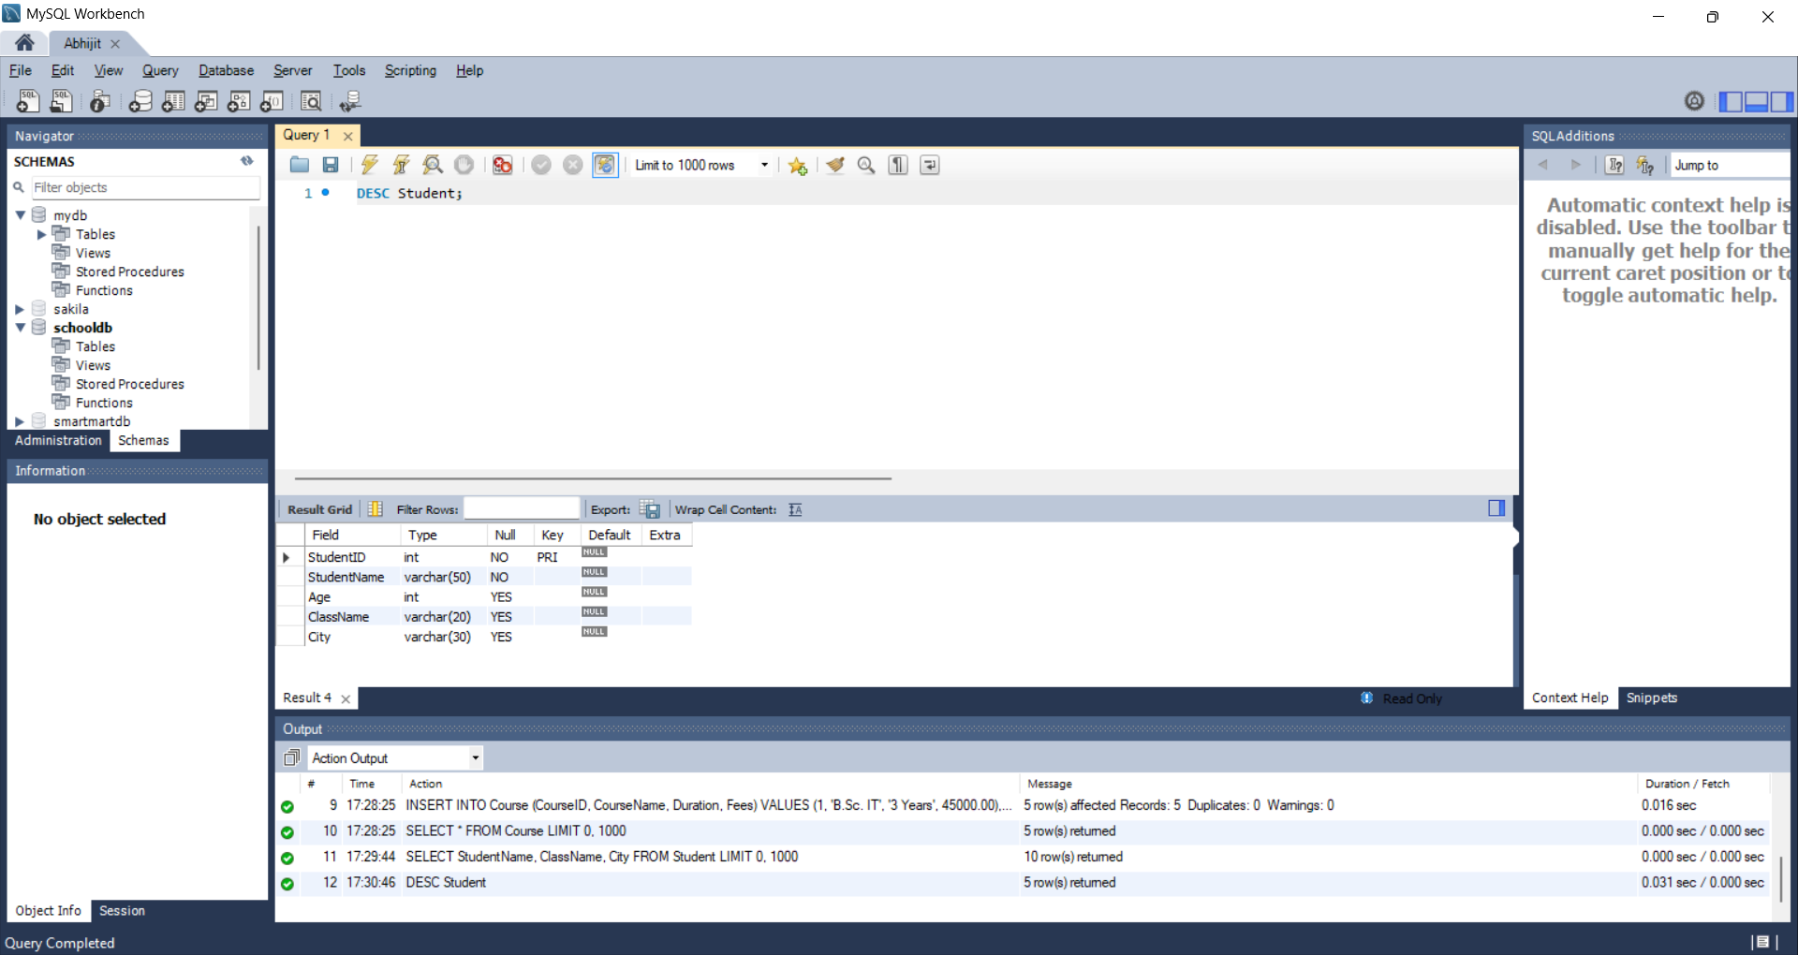

A.7
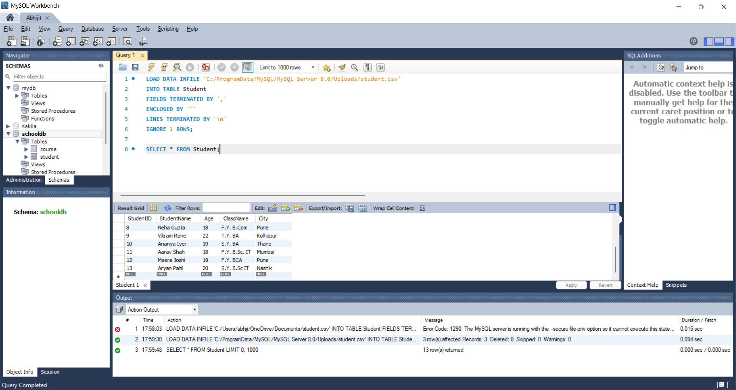
A.8
CREATE DATABASE EmployeeDB;
USE EmployeeDB;

CREATE TABLE Employee(EmployeeID INT PRIMARY KEY,
EmployeeName VARCHAR(50) NOT NULL,
Department VARCHAR(30),
Salary DECIMAL(10, 2),
City VARCHAR(30));

INSERT INTO Employee (EmployeeID, EmployeeName, Department, Salary, City) VALUES
(1, 'Rahul Mehta', 'IT', 55000.00, 'Pune'),
(2, 'Sneha Kapoor', 'HR', 42000.00, 'Mumbai'),
(3, 'Amit Verma', 'Finance', 60000.00, 'Nashik'),
(4, 'Pooja Nair', 'Marketing', 48000.00, 'Pune'),
(5, 'Vikas Singh', 'IT', 58000.00, 'Nagpur'),
(6, 'Divya Rao', 'Finance', 52000.00, 'Mumbai'),
(7, 'Karan Malhotra', 'Sales', 45000.00, 'Thane'),
(8, 'Ritu Chawla', 'HR', 40000.00, 'Aurangabad');

SELECT * FROM Employee;
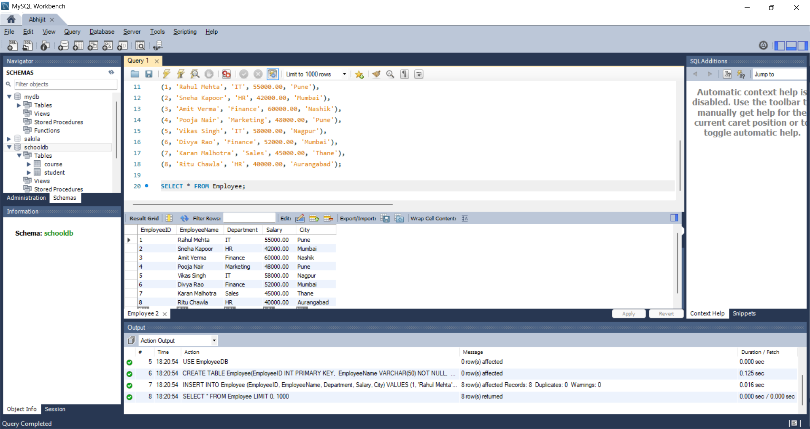

A.9
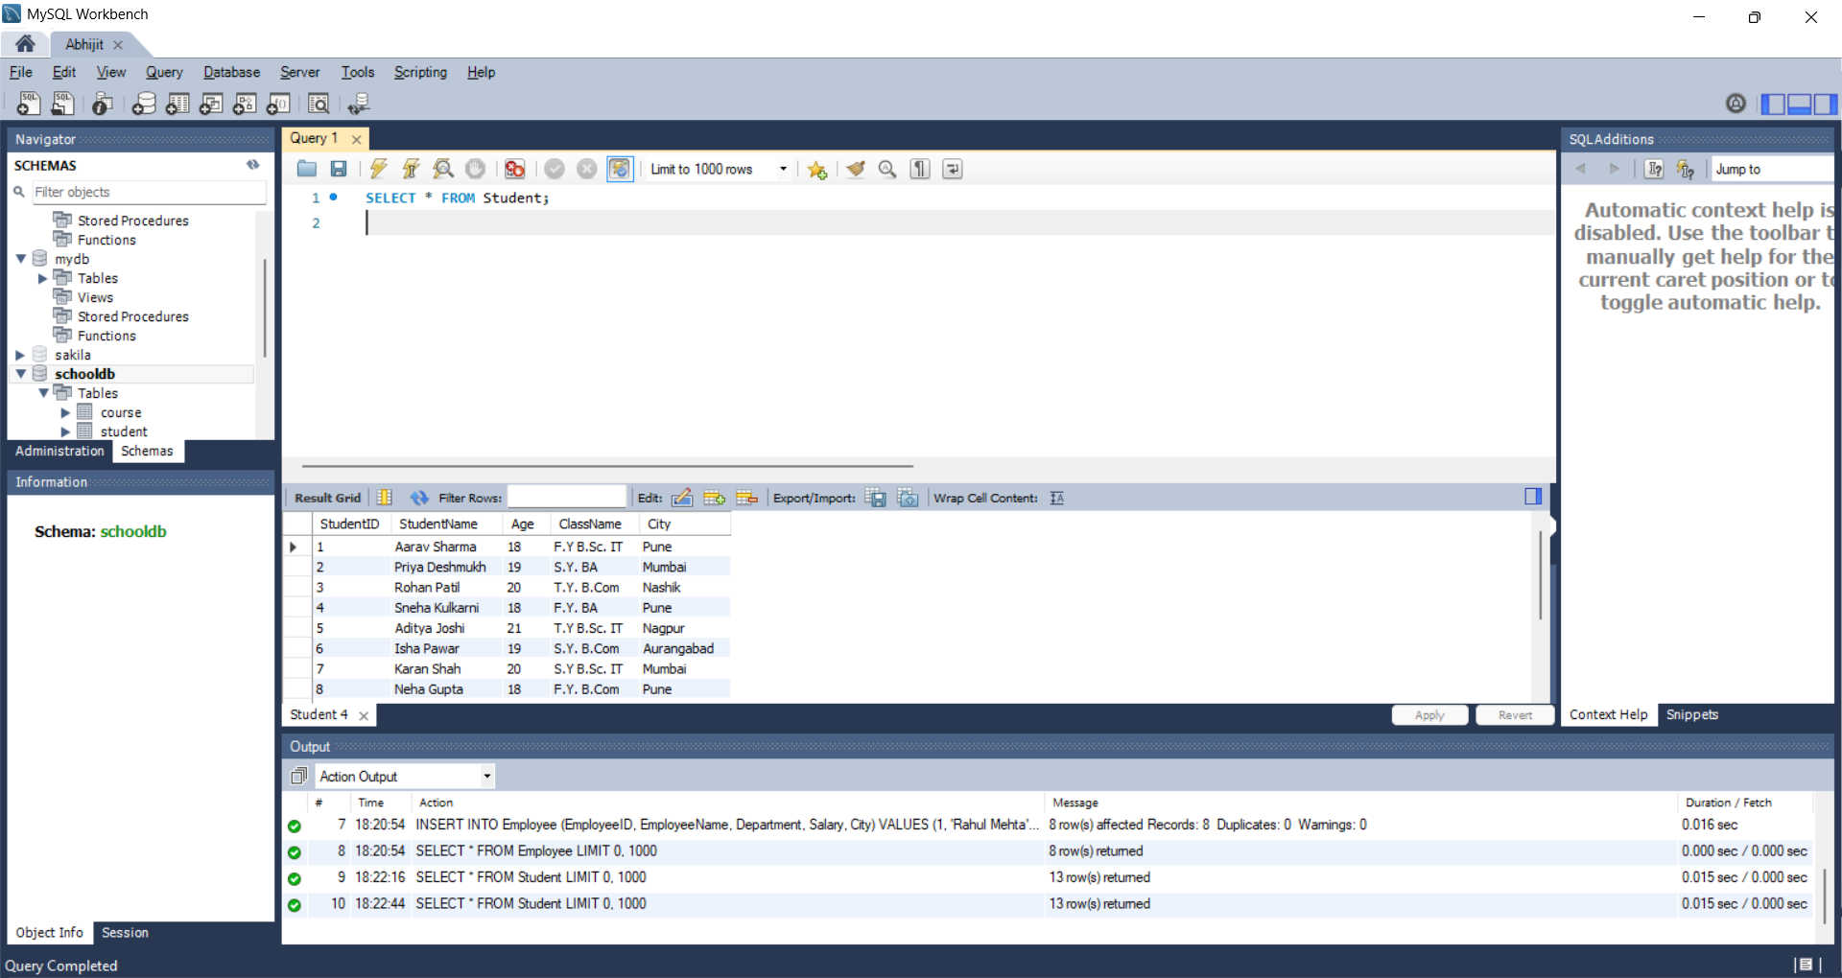

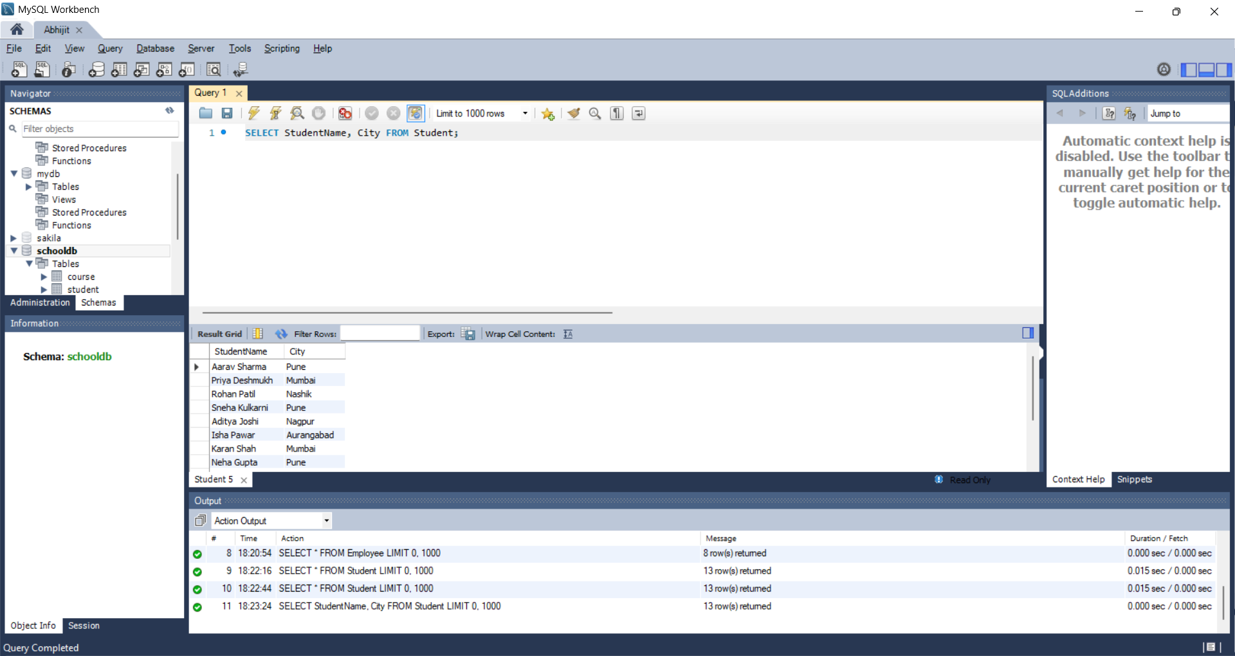

In both these queries, we see that the first one shows all rows and columns in the table, while the second one shows all rows but only selected columns of the table.

A.10
-- Database created
CREATE DATABASE MiniCollegeDB;
USE MiniCollegeDB;
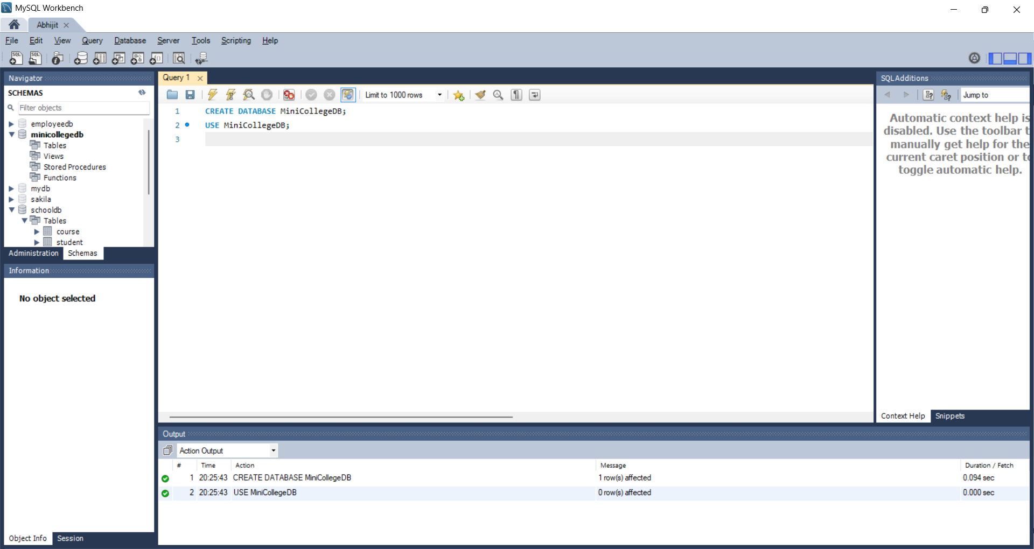

-- Tables created
CREATE TABLE Student(StudentID INT PRIMARY KEY,
StudentName VARCHAR(50) NOT NULL,
Age INT,
ClassName VARCHAR(20),
City VARCHAR(30));

CREATE TABLE Course(CourseID INT PRIMARY KEY,
CourseName VARCHAR(50) NOT NULL,
Duration VARCHAR(20),
Fees DECIMAL (10, 2));

CREATE TABLE Faculty (
FacultyID INT PRIMARY KEY,
FacultyName VARCHAR(50) NOT NULL,
Department VARCHAR(30)
);
-- Values Inserted
INSERT INTO Student (StudentID, StudentName, Age, ClassName, City) VALUES
(1, 'Aarav Sharma', 18, 'F.Y B.Sc. IT', 'Pune'),
(2, 'Priya Deshmukh', 19, 'S.Y. BA', 'Mumbai'),
(3, 'Rohan Patil', 20, 'T.Y. B.Com', 'Nashik'),
(4, 'Sneha Kulkarni', 18, 'F.Y. BA', 'Pune'),
(5, 'Aditya Joshi', 21, 'T.Y B.Sc. IT', 'Nagpur'),
(6, 'Isha Pawar', 19, 'S.Y. B.Com', 'Aurangabad'),
(7, 'Karan Shah', 20, 'S.Y B.Sc. IT', 'Mumbai'),
(8, 'Neha Gupta', 18, 'F.Y. B.Com', 'Pune'),
(9, 'Vikram Rane', 22, 'T.Y. BA', 'Kolhapur'),
(10, 'Ananya Iyer', 19, 'S.Y. BA', 'Thane');

INSERT INTO Course (CourseID, CourseName, Duration, Fees) VALUES
(1, 'B.Sc. IT', '3 Years', 45000.00),
(2, 'BA', '3 Years', 20000.00),
(3, 'B.Com', '3 Years', 25000.00),
(4, 'BCA', '3 Years', 50000.00),
(5, 'MCA', '2 Years', 60000.00);

INSERT INTO Faculty VALUES
(1, 'Dr. Amit Joshi', 'Computer Science'),
(2, 'Prof. Neha Shah', 'IT'),
(3, 'Dr. Rohan Patil', 'Data Science'),
(4, 'Prof. Sneha More', 'Cyber Security'),
(5, 'Prof. Karan Mehta', 'Mathematics');
-- Tables shown
SELECT * FROM Student;
SELECT * FROM Course;
SELECT * FROM Faculty;
-- Table Structures shown
DESC Student;
DESC Course;
DESC Faculty;

